Hosting a NodeJS application via Elastic Beanstalk Service provided by AWS(Amazon Web Services).

1. Log on to the AWS and navigate to the console.
2. Select your desired region. I have selected North Virginia in my case.

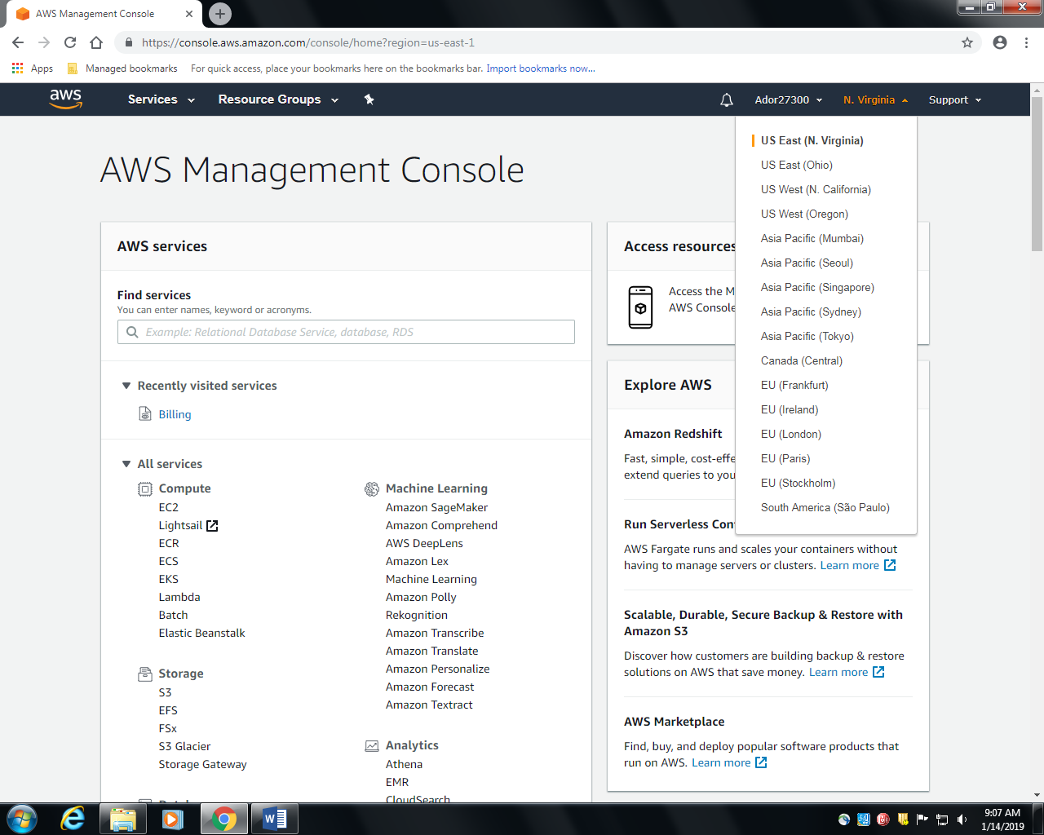

1. In the ‘**All Services**’ dropdown select **Elastic Beanstalk.**

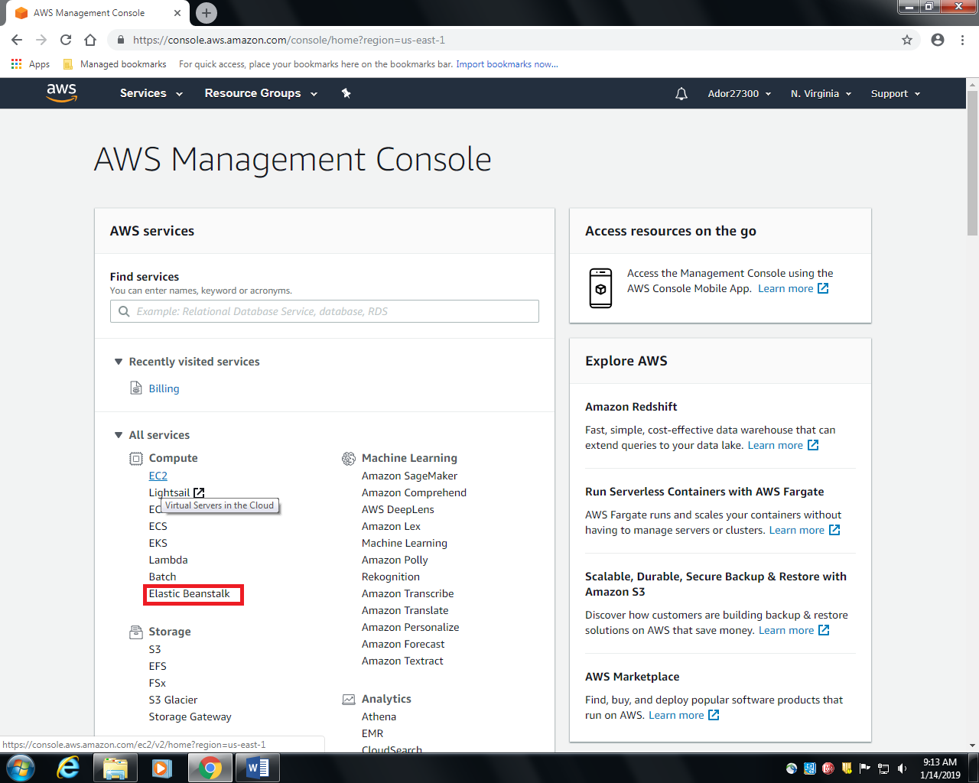

1. Select **Create New Application** at the top right corner.

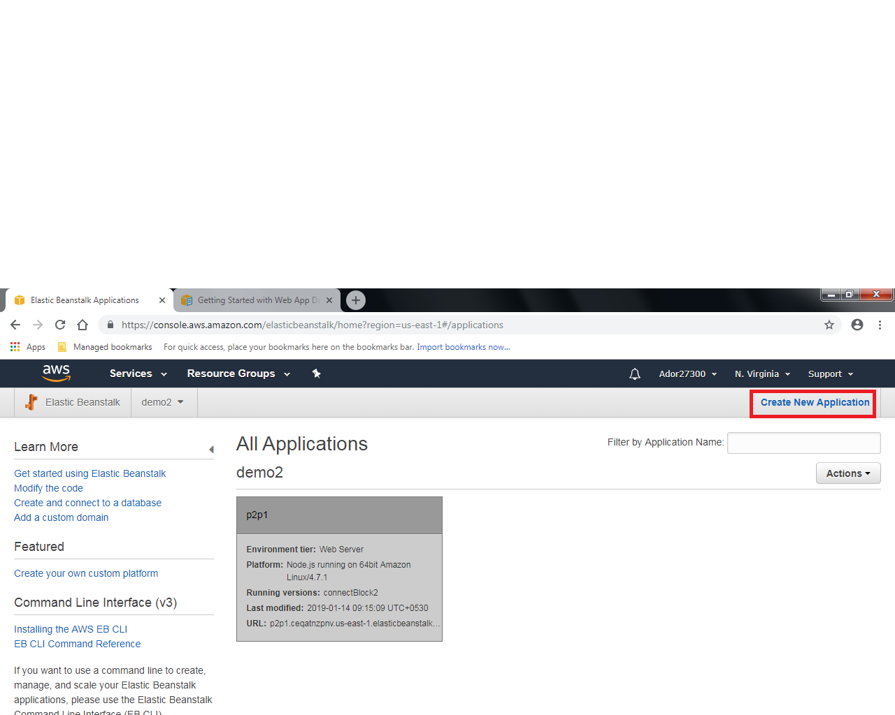

1. Write the desired application name and the appropriate description.

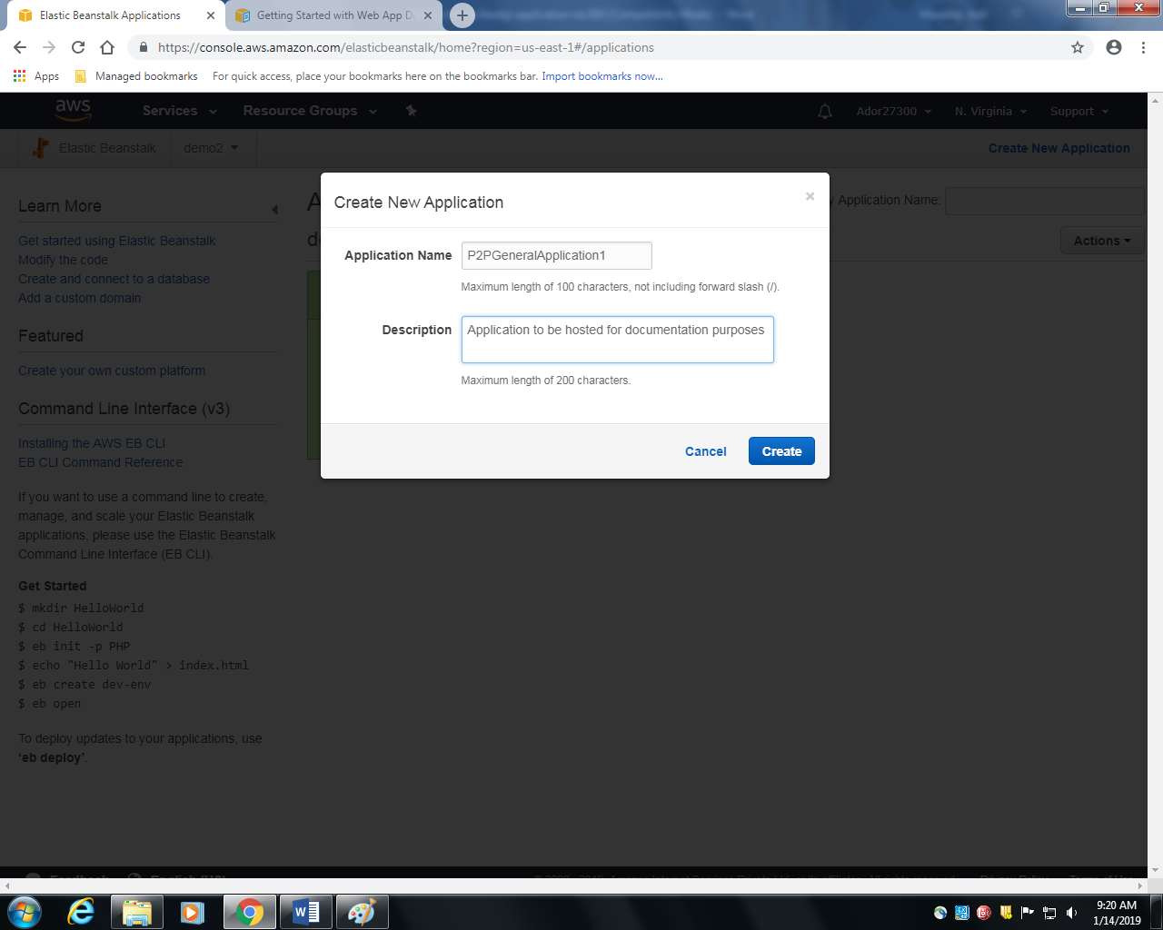

1. Click on **Create.**
2. You will be redirected to the following page. Now we need to create an environment. Click on **Create one now.**

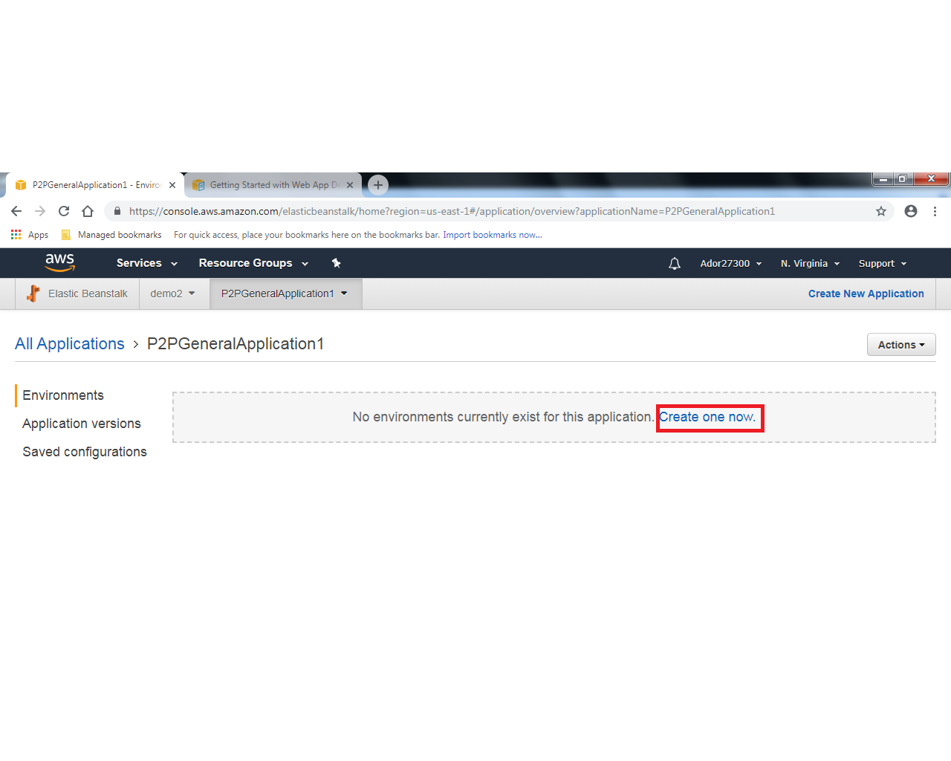

1. Select **Web Server Environment**

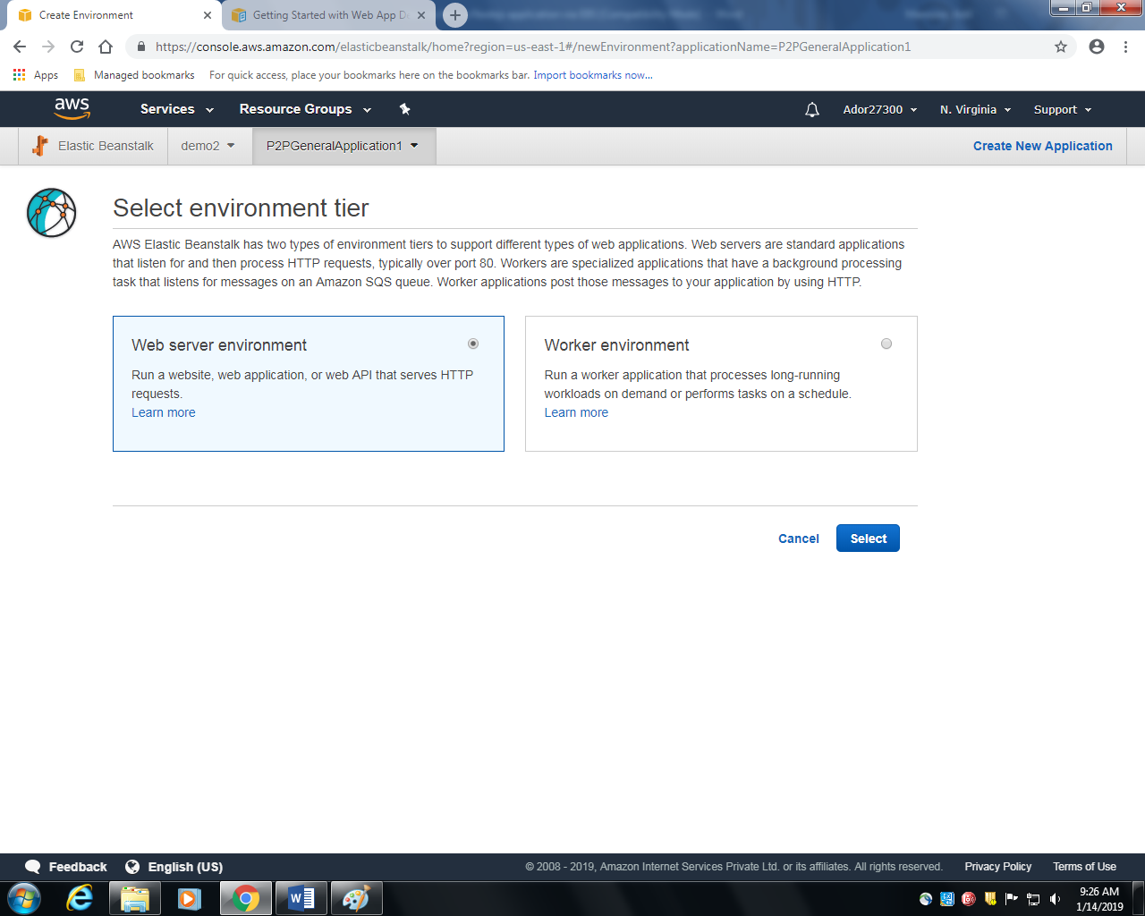

1. You will be redirected to the following page.

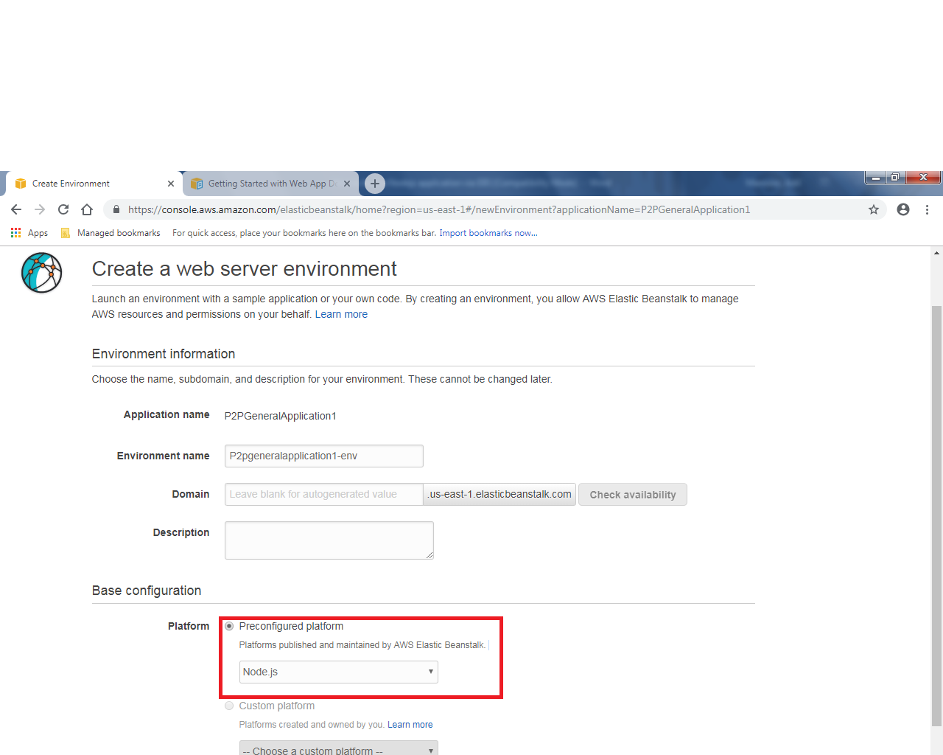

1. In the **Base configuration -> Platform ->Preconfigured platform-> Select ‘NodeJS’** in the dropdown as show in the above image.
2. In the **Base configuration-> Application Code-> Select ‘Upload your code’** and click on upload.

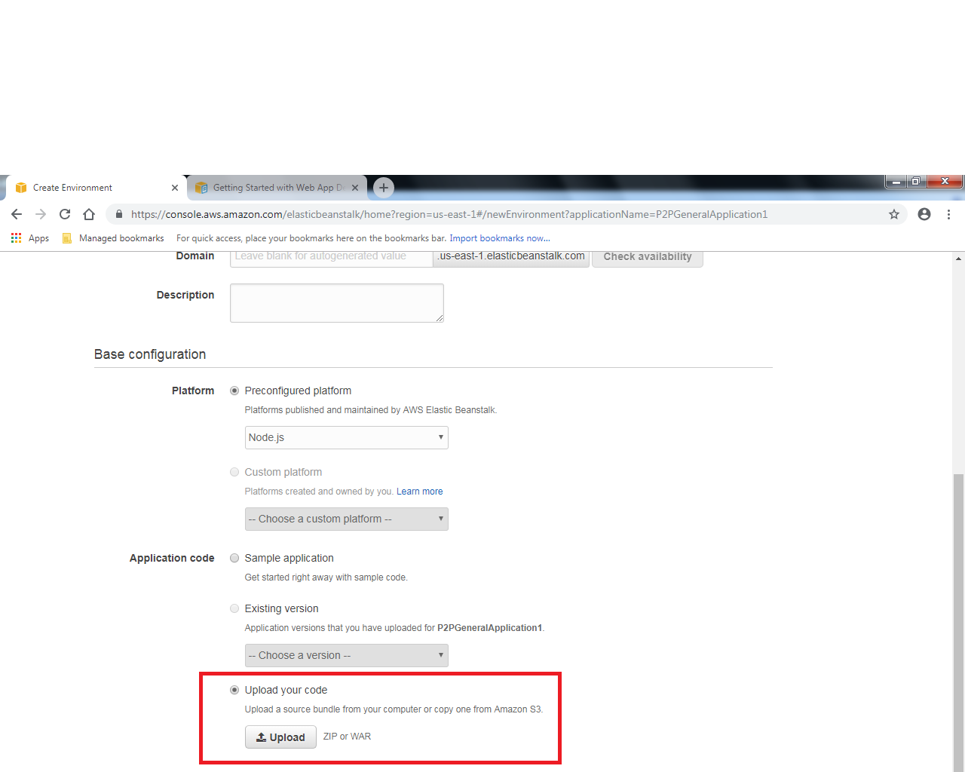

12)

Before uploading,

we need to do 2 important things. First create a **.npmrc** file in which we will write the conditions on how we need to run the npm install command. There is indeed a ‘ **.** ‘(dot) before the file name (npmrc) and it is not a mistake.

­­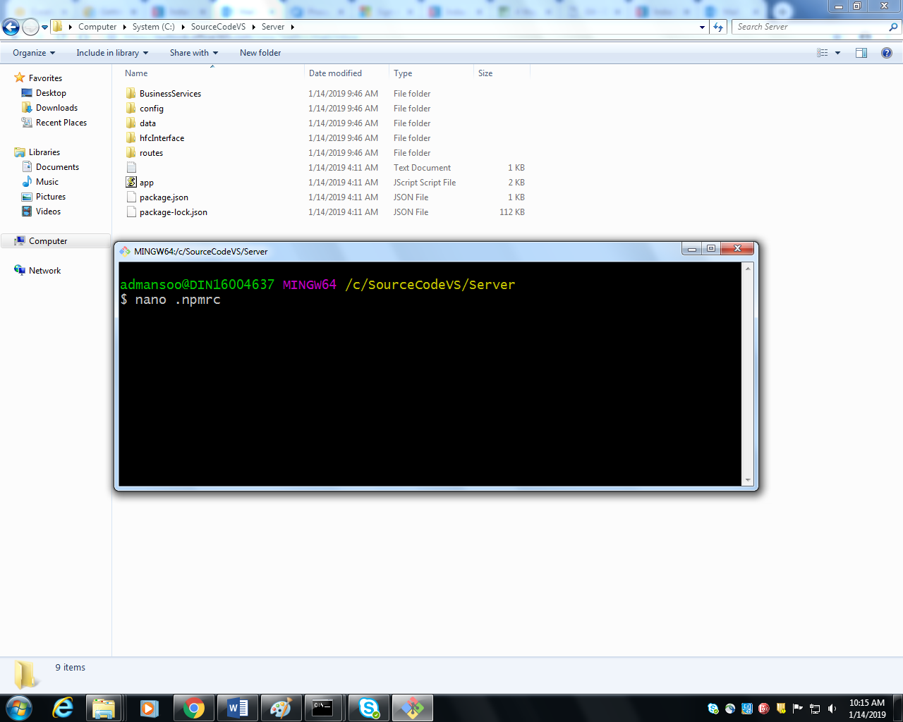

In the above file write the following text.

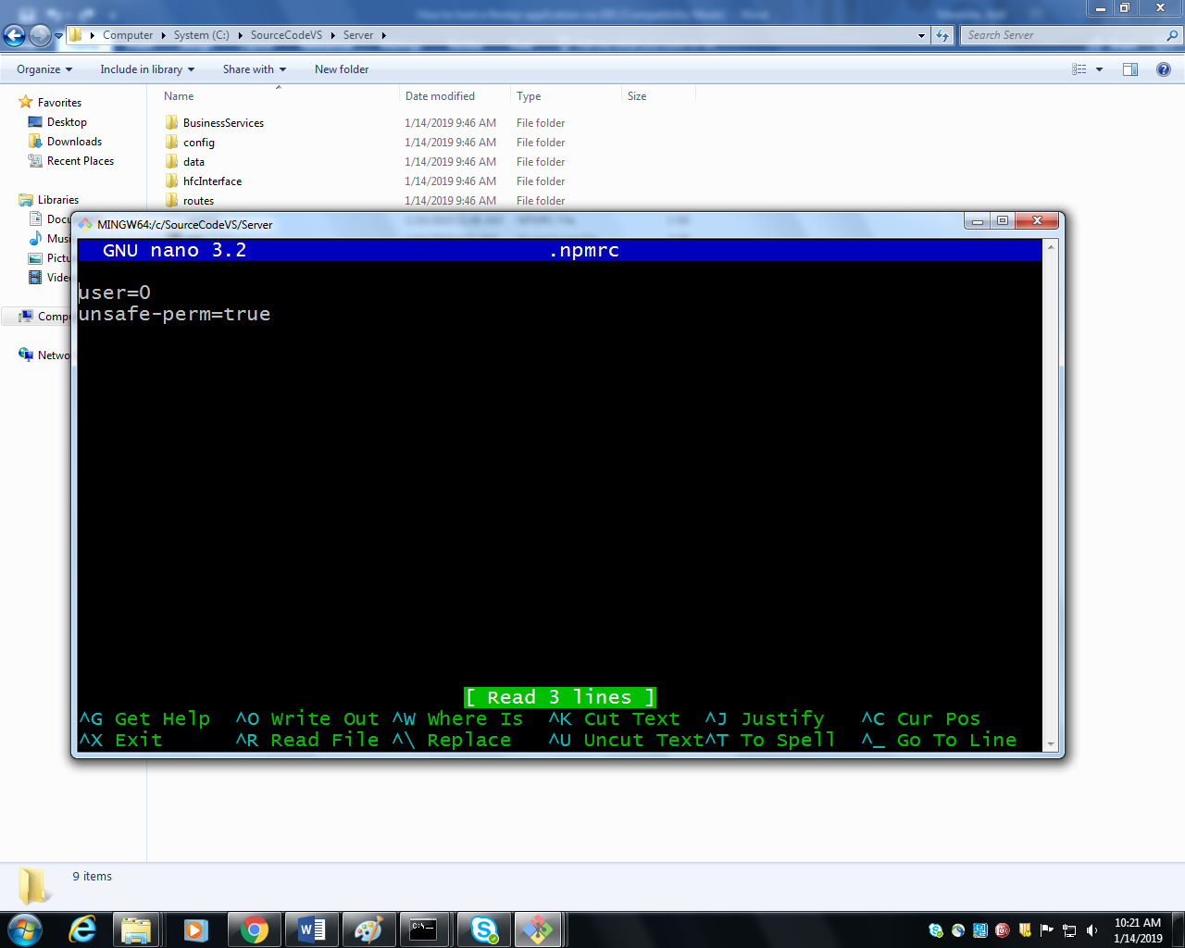

Then **Ctrl + 0 - > Enter -> Ctrl + X (Write out -> Confirm File Name -> Exit)**

The **Server** directory contains my NodeJS code. **DO NOT DIRECTLY ZIP THE WHOLE FOLDER. ZIP ONLY THE CONTENTS(without node modules). PLEASE REFER TO IMAGES BELOW.**

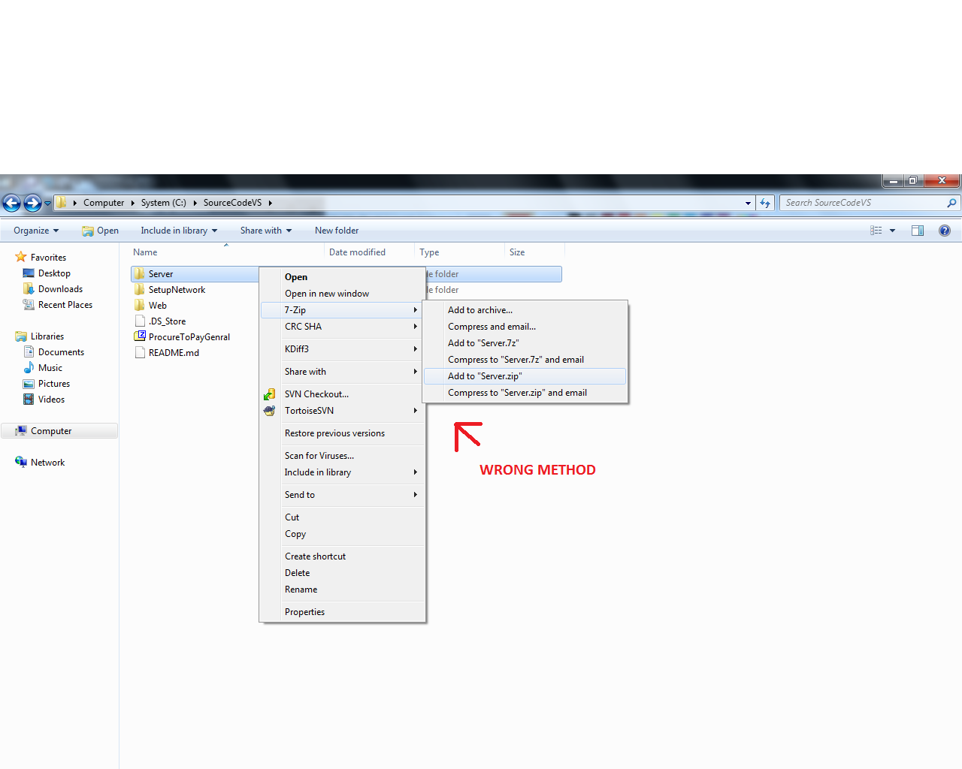

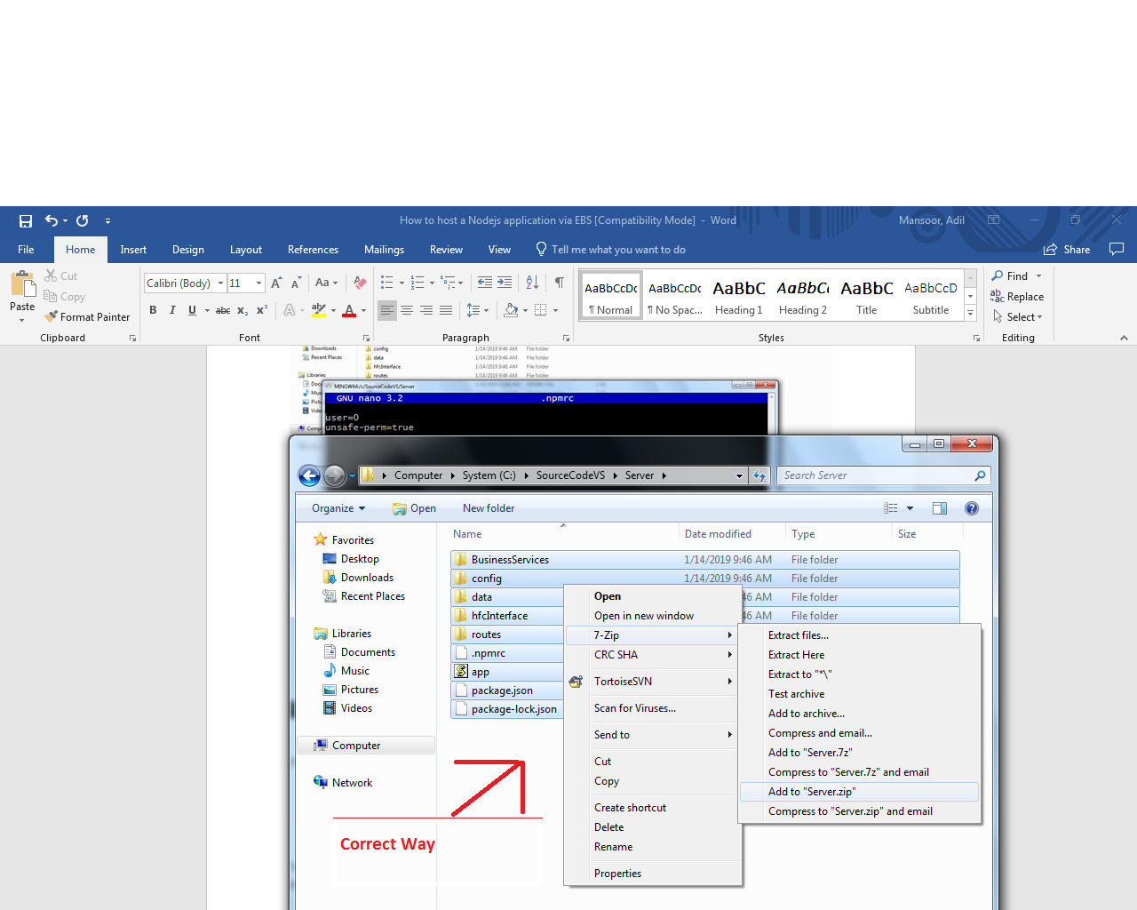

13)

Select the folder in which you have zipped the contents and click on upload.

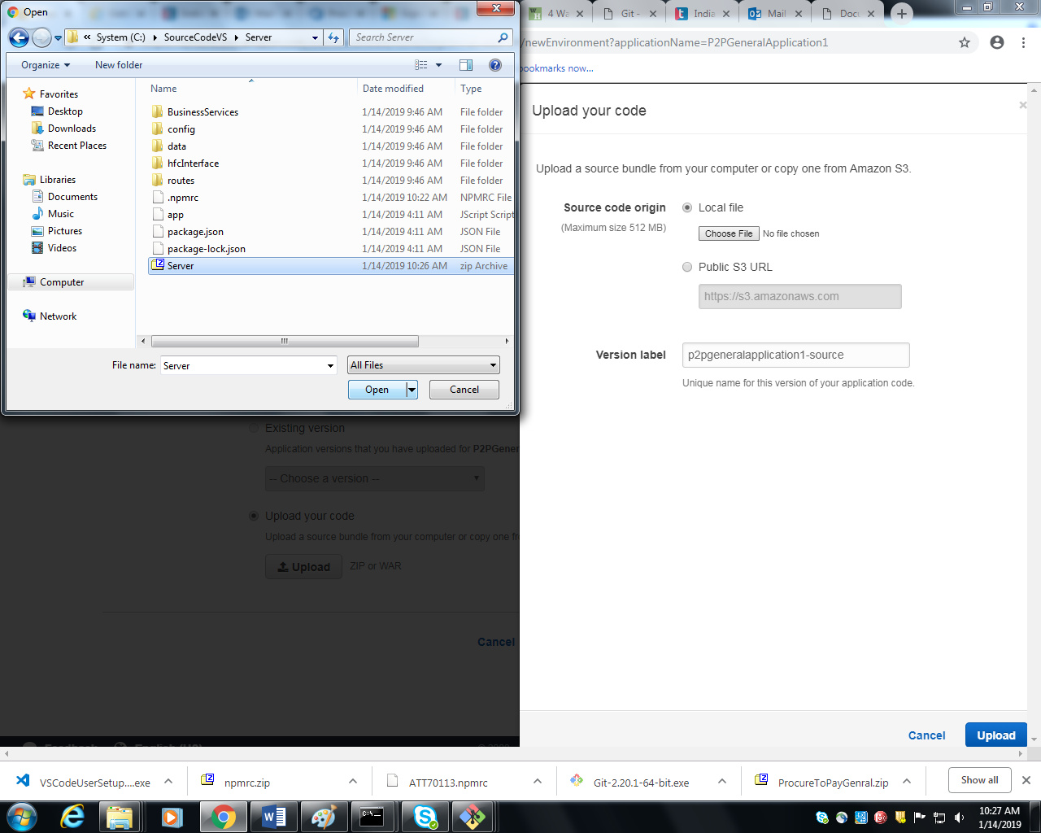

14) Now we need to configure the nodeJS version and do some extra settings if required. For that click on **Configure More Options** as shown in image below.

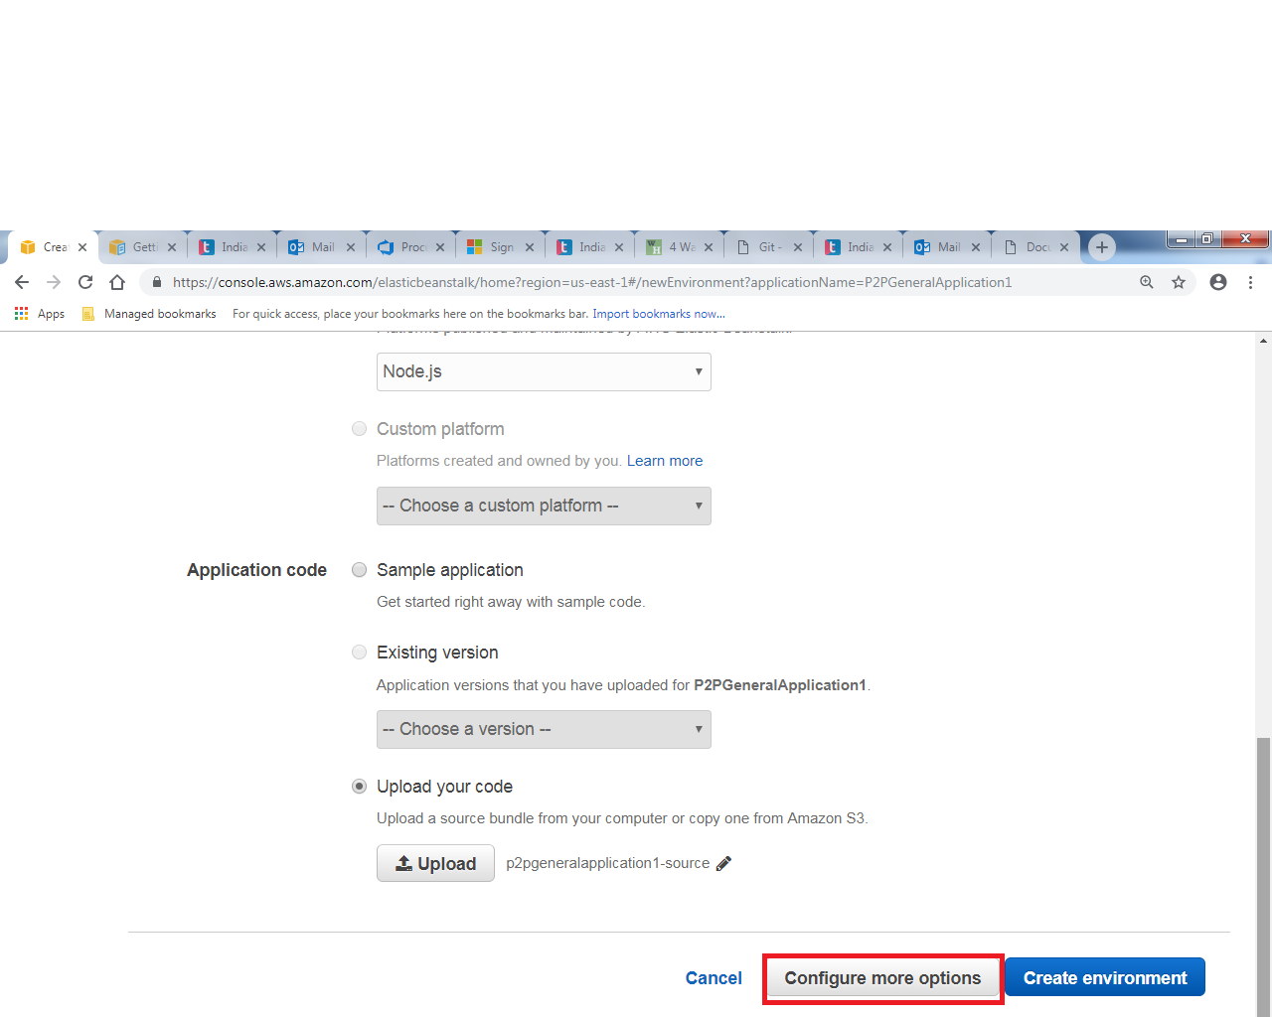

15) You can see that in the software section the default nodeJS version provided as of 14/1/2019 is 10.14.1. If you wish to change the nodeJs version , click **modify** and select the appropriate nodejs version as shown in below 2 images.

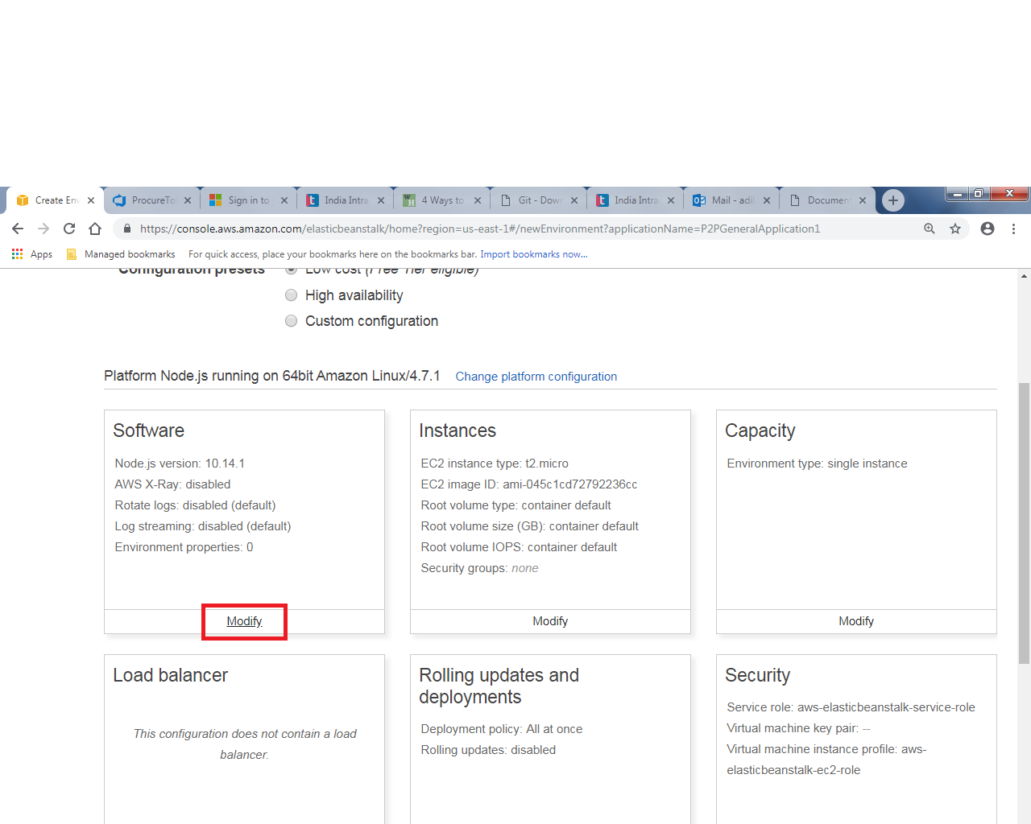

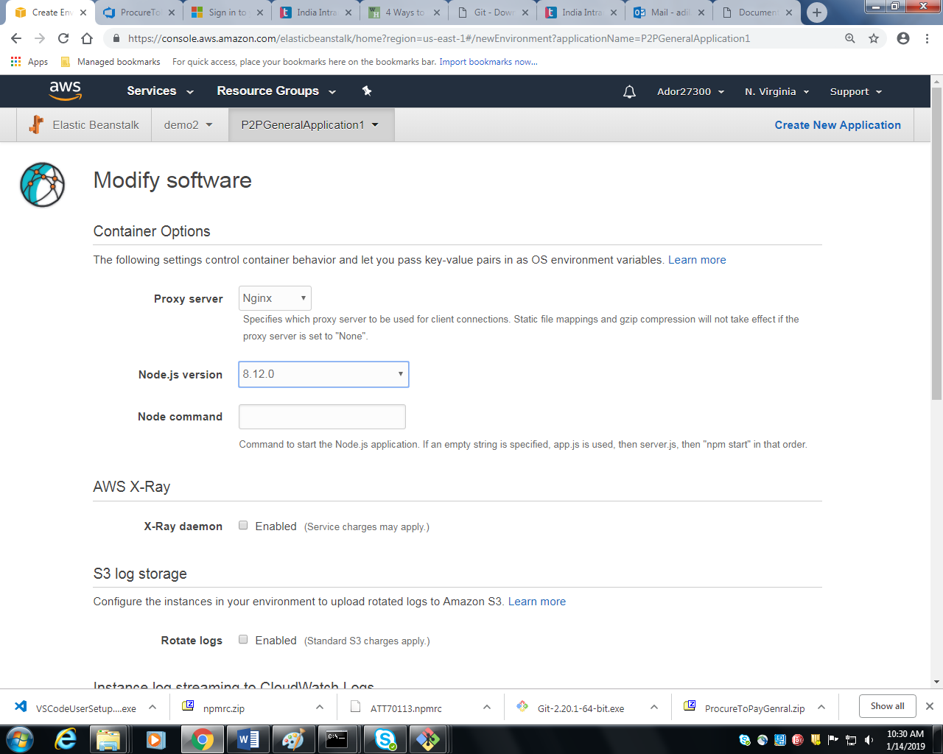

16) Click on **save** (scroll down) after implementing the changes.

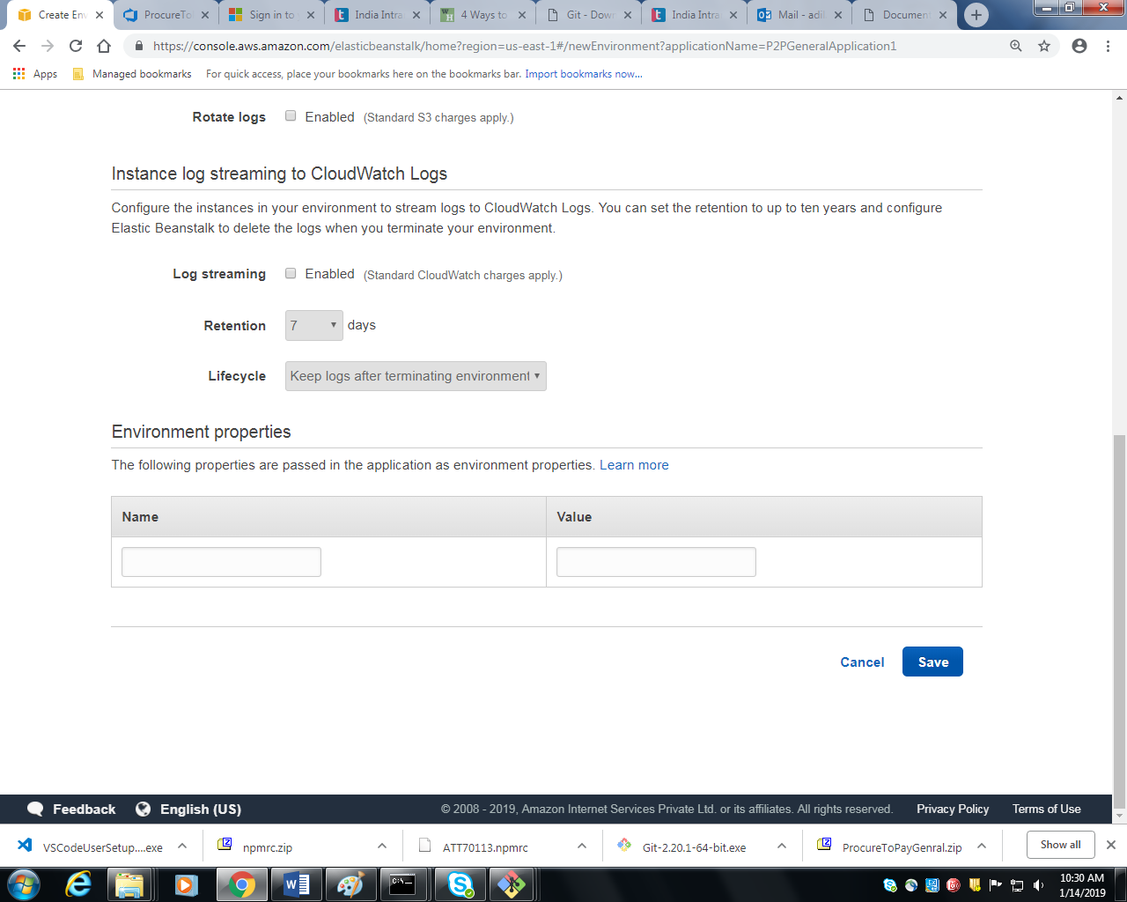

17) If you wish to make changes in the security group, click on **modify** in the security section. You can add key value pair if you wish to.

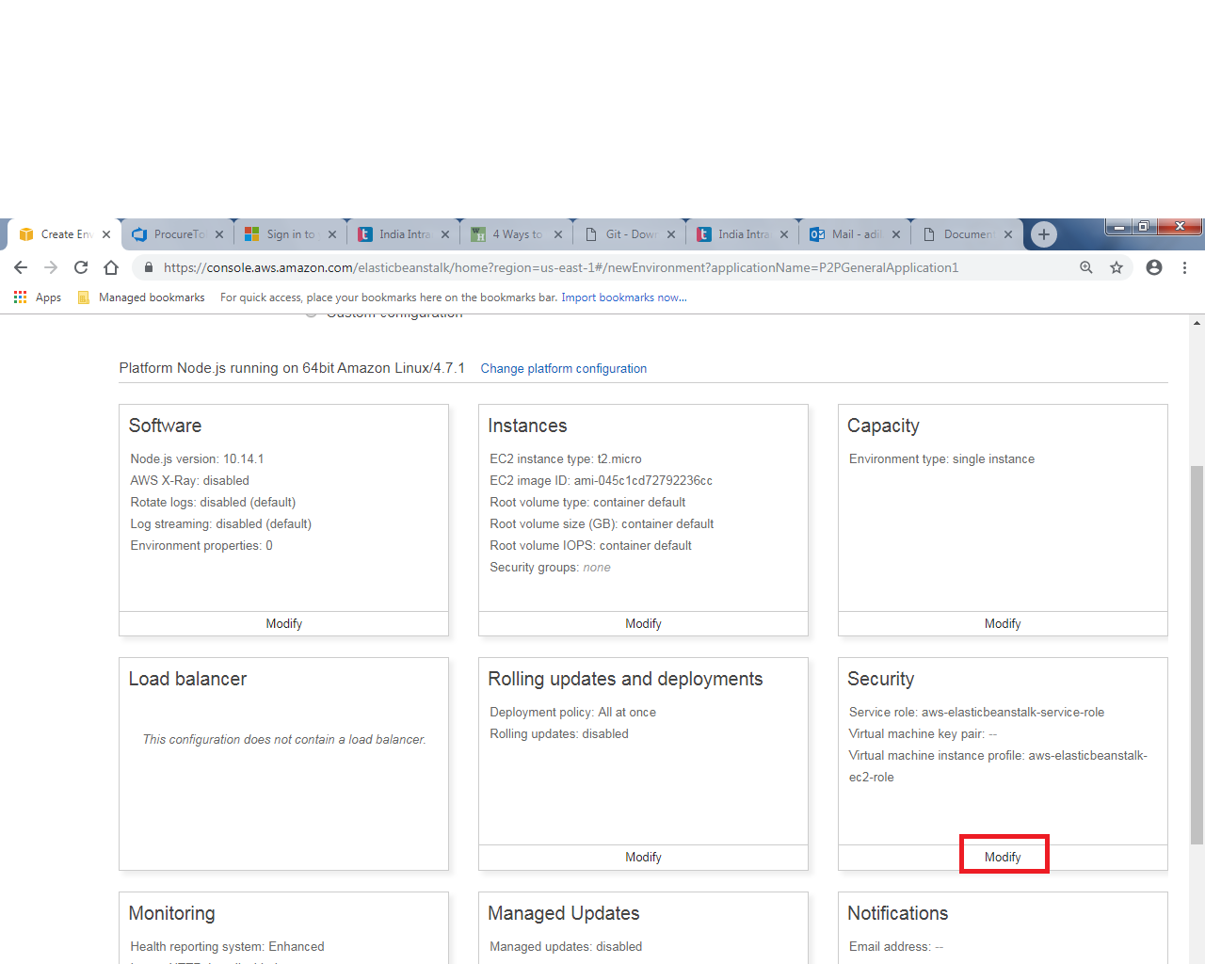

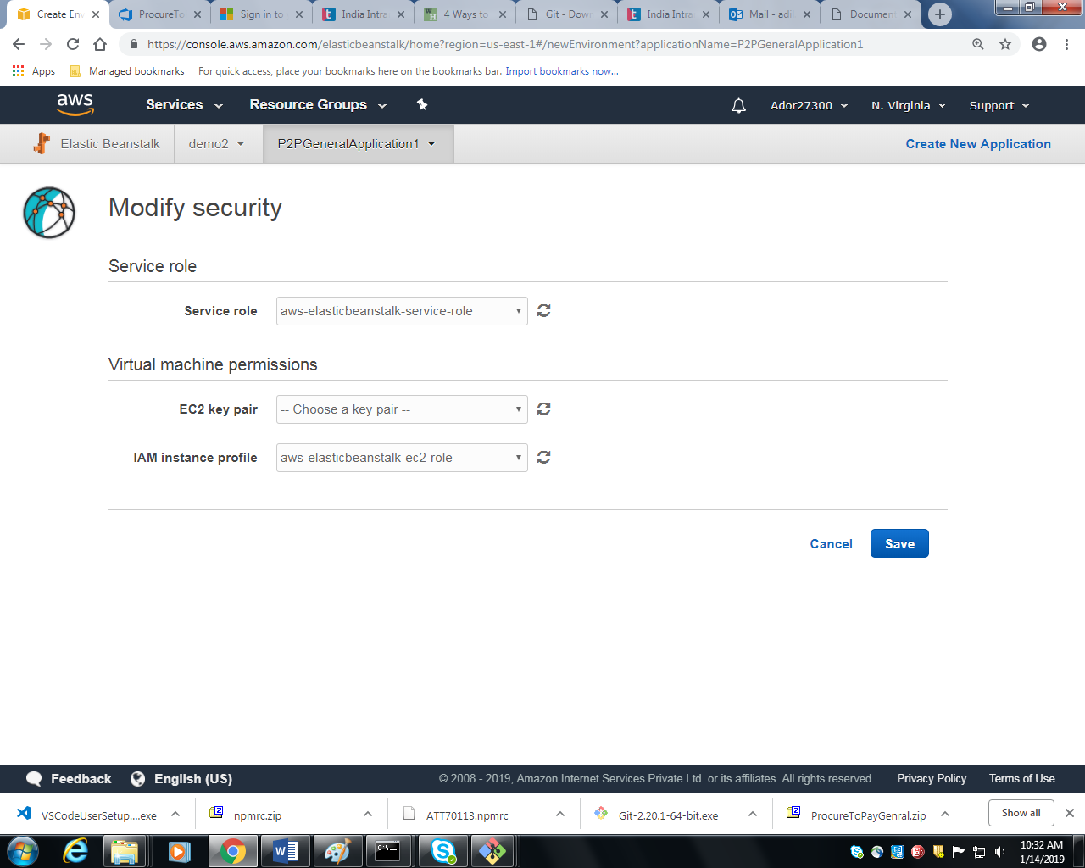

18) You can make changes in other section if you wish to. After making the changes , click on create environment at the bottom right as shown in the image below.

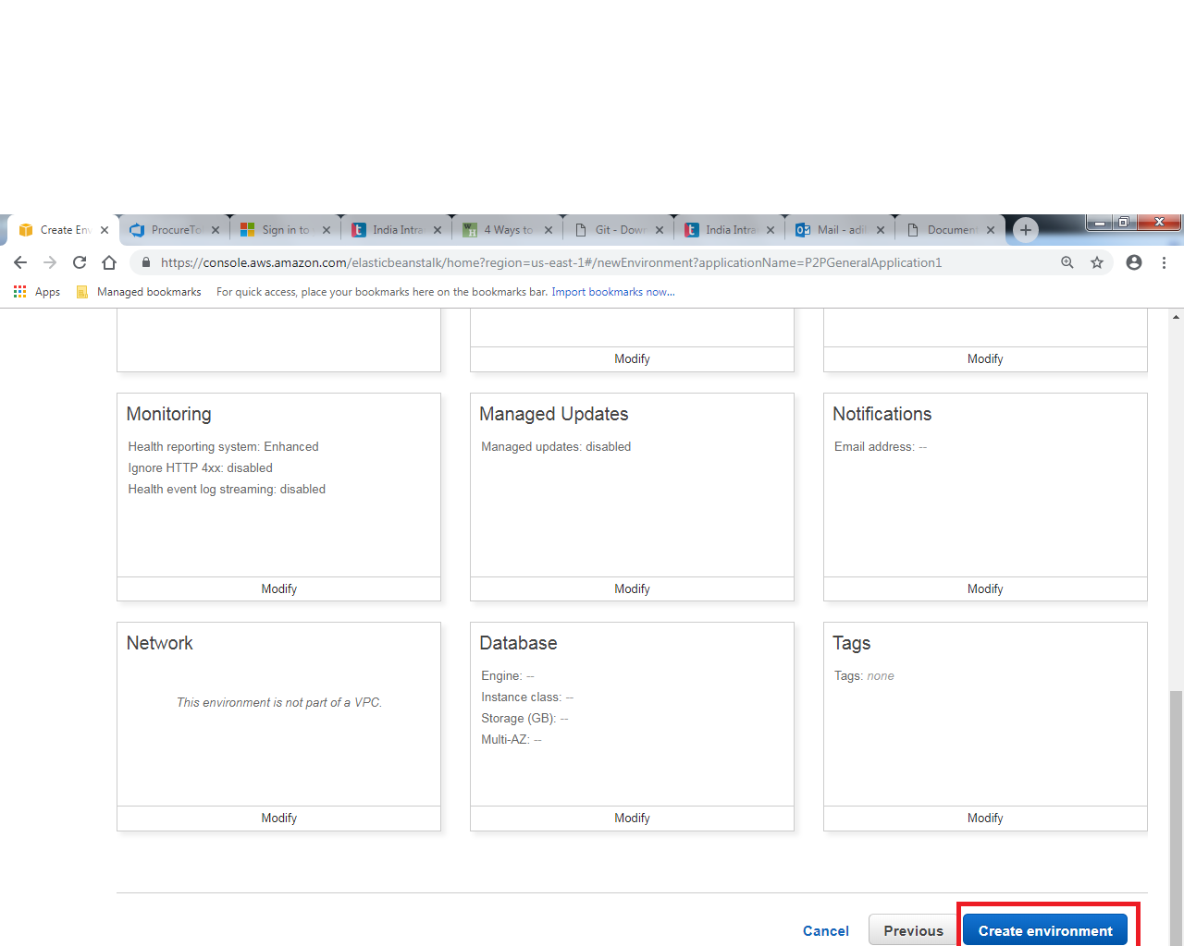

19) You can see that the process has been started.

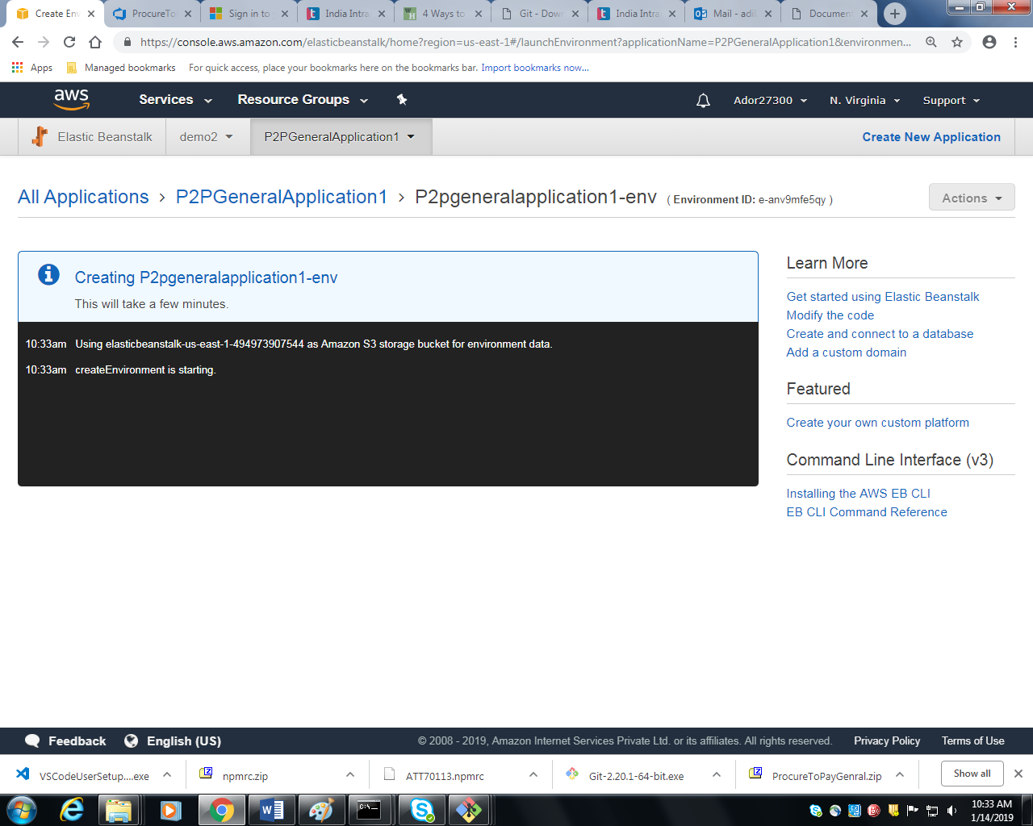

20) If everything goes alright , you will see the health of the application as ok and in green color.

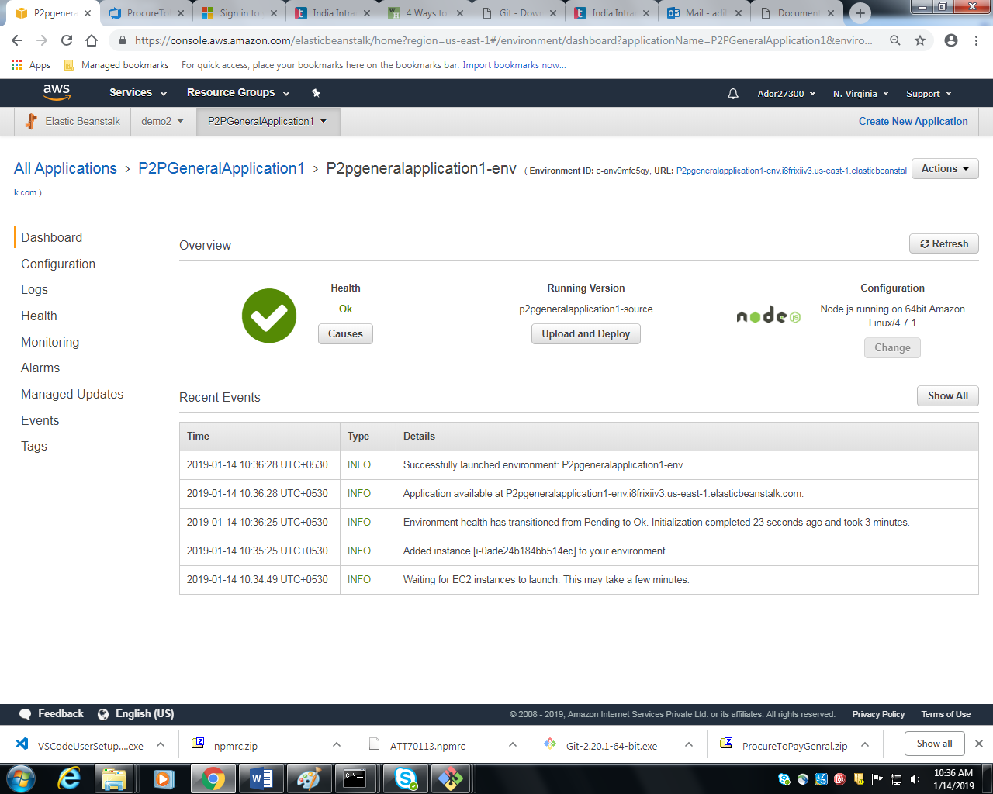

21) The endpoint for your application is shown at the top as shown in the image below.

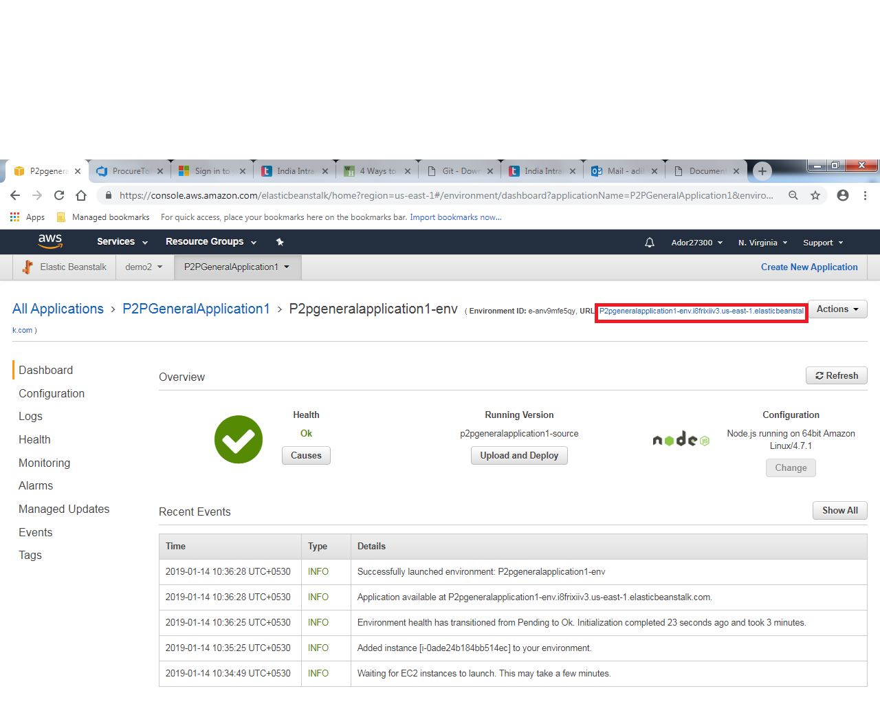

22 ) Feel free to test your api.

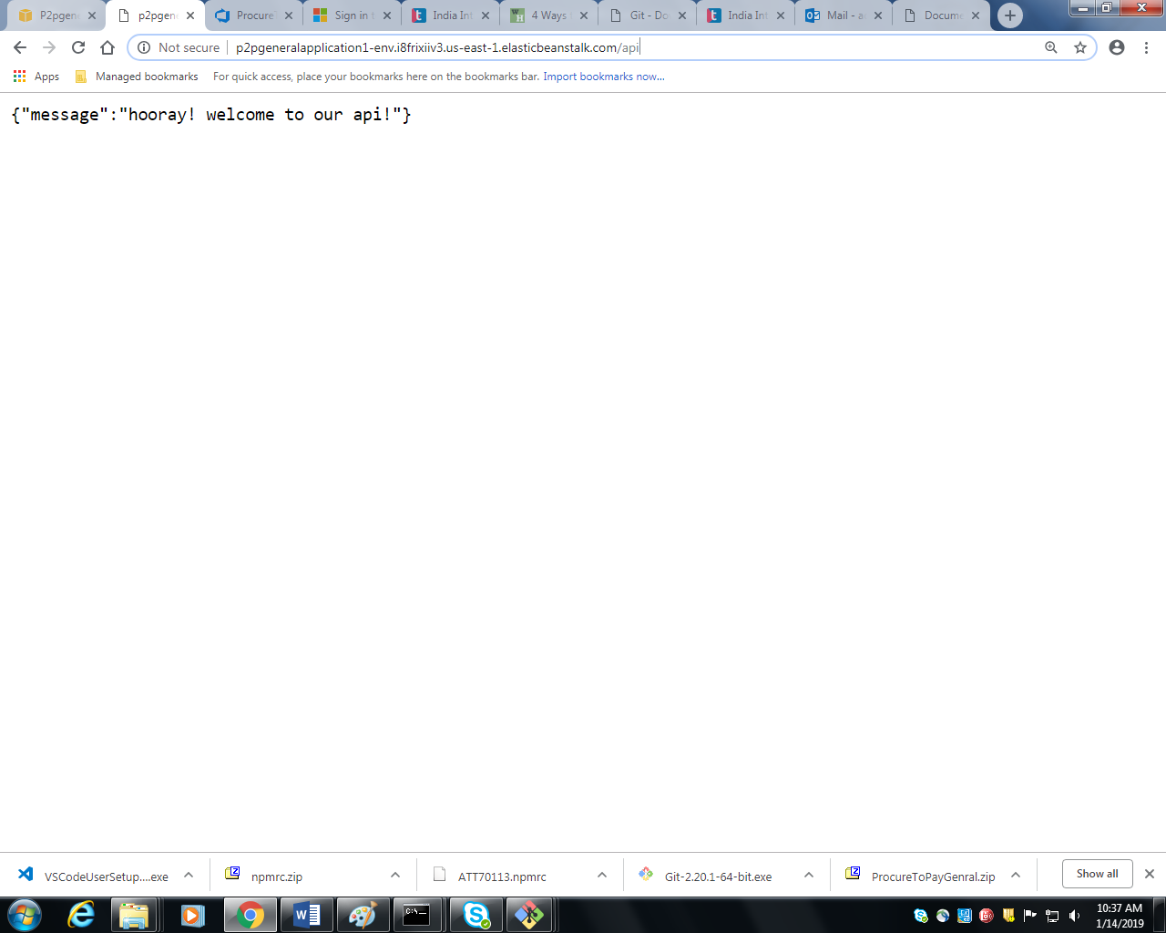

23) You can view the logs by clicking on **logs** section on the left hand side and after that click on **request logs** dropdown on the right hand side.

